Name:- Document-1

- Answer:- REST: Rules for designing APIs using HTTP.
It follows principles like:
Stateless: Server doesn’t remember anything about the user between requests.
Resources: Everything is a resource (users, products, etc.)
Uses HTTP methods like GET, POST, PUT, DELETE.
Web API: A type of RESTful service. We build it using .NET so that other apps or frontend (like React/Angular) can talk to our server.
WebService vs WebAPI:
Web Service | Web API
SOAP-based | REST-based
Returns XML | Returns XML/JSON
Heavy | Lightweight
Microservice: Breaking big applications into small independent services. Each does one job and talks to others via APIs.
- Answer:-

HttpRequest: What your browser/app sends to the server (e.g., "Hey, give me user list").
HttpResponse: What server sends back (e.g., "Here are the users").

HTTP Status Codes
These are response codes returned by the server:
Code | Meaning
500 InternalServerError | Server failed
400 BadRequest | Invalid input
401 Unauthorized | Login needed
200 ok | Success

MyFirstWebAPI
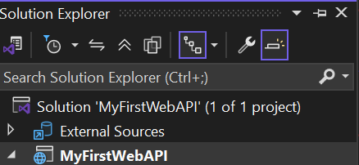

Created Controller
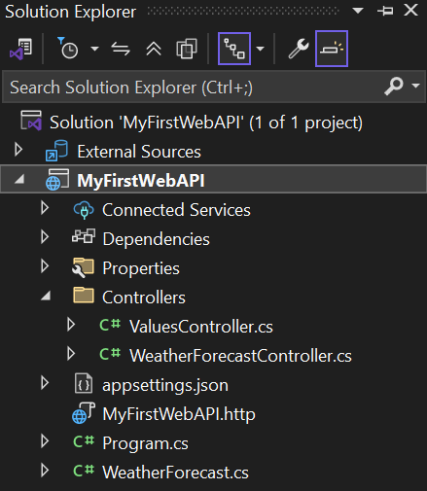
Code For ValuesController.cs in MyFirstWebAPI

using Microsoft.AspNetCore.Mvc;

namespace MyFirstWebAPI.Controllers
{
[ApiController]
[Route("api/[controller]")]
public class ValuesController : ControllerBase
{
[HttpGet]
public ActionResult<IEnumerable<string>> Get()
{
return new string[] { "value1", "value2" };
}
[HttpGet("{id}")]
public ActionResult<string> Get(int id)
{
return $"You requested value {id}";
}
[HttpPost]
public IActionResult Post([FromBody] string value)
{
return Ok($"You posted: {value}");
}
[HttpPut("{id}")]
public IActionResult Put(int id, [FromBody] string value)
{
return Ok($"You updated ID {id} with value {value}");
}
[HttpDelete("{id}")]
public IActionResult Delete(int id)
{
return Ok($"You deleted value with ID {id}");
}
}
}

